Question 1
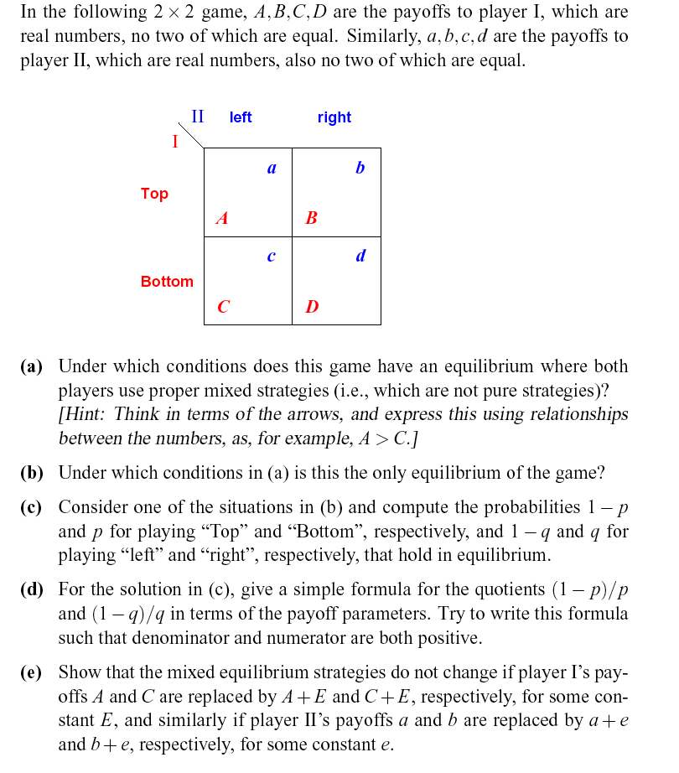

Question 2
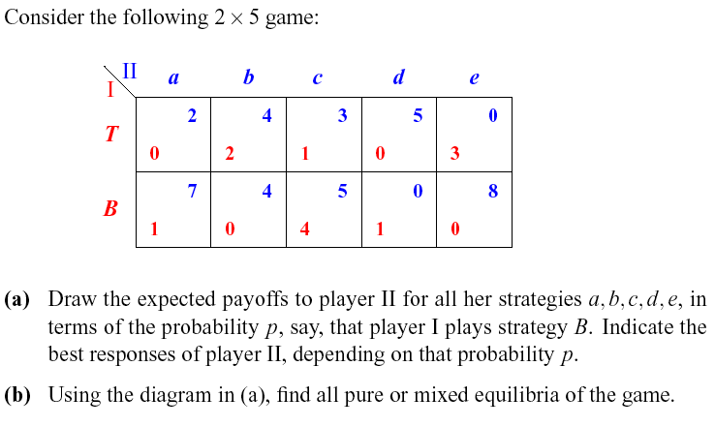

Question 3 Which one of the two games given below is of perfect recall and which is not? Translate the one with perfect recall into strategic form, and compute all Nes, SPNEs and Ses.
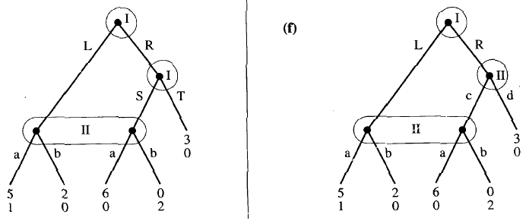

Question4
(a) Michael has an initial wealth of $20000. In an NBA game of Lakers against Bulls, he bids with $10000 : $20000 in favor of Lakers. (He wins $10000 if Lakers wins and he looses $20000 if Bulls wins, assuming the probability for a tie is 0.) What is Michael’s minimal subjective probability for Lakers’ winning of the game? Assuming Michael has a Bernoulli utility function w^{1/2}.

(b) Jenny is making a decision to choose between a law degree and a science degree in graduate studying. As a lawyer her lifetime income (present value) is 81 if she becomes a star lawyer or only 4 if she becomes a mediocre one. As a scientist her lifetime income is 25 with certainty. Jenny knows that the chance for being a star lawyer is 0.1. A fortune-teller can completely foresee whether or not Jenny will be a star lawyer when she studies for a law degree. Assume Jenny’s Bernoulli utility function is w^{1/2}. What is the highest amount Jenny would like to pay for a consultation with the fortune-teller.

Question 5 There two states of nature: good state and bad states. There are two types of customers: high-risk type and low-risk type, each has a probability of 0.2 and a probability of 0.05 to be in bad state. Every customer has a wealth of 250000 in good state, and a wealth of 90000 in bad state. A competitive insurance firm is offering fair insurance contract.

(a) If the insurer can tell the type of any customer, what will be the contracts supporting an equilibrium? Explain your result by a simple graph with contract curves and the equilibrium contract points.

(b) Suppose the insurer cannot tell the type of a customer. Suppose the population of customers consists of half of high-risk type customers and half of low-risk customers. Suppose the insurer wants to offer a pooling contract. Verify that any pooling contract looks like (0.125q,q), where q is the cover and 0.125q is the premium. Given the optimal pooling contract for the low-risk (1785.75,14286). Explain with a graph as to why this contract cannot support a pooling equilibrium.

(c) If a separating equilibrium exists, what is the contract for the high-risk and what is the contract for the low-risk?

Question 6 Solve the Principal-Agent problem as depicted in the game tree in the filePA.ppt. Assuming R=20, r=10, E=6, e=2; and consider two cases: (a) Π=0.8, π=0.3; and (b) Π=0.8, π=0.7.

